1. We talked about the authorities, roles, privileges to control
   1. User level access and
   2. User level actions.
2. Where these (roles, authorities) are stored?  
   **Answer**: UserDetails.
3. **UserDetails**: It is a contract by Spring Security where all the info about an end user is stored.
   1. It includes
      1. Authentication Details 🡺 Username, password, email.
      2. Authorities.
4. 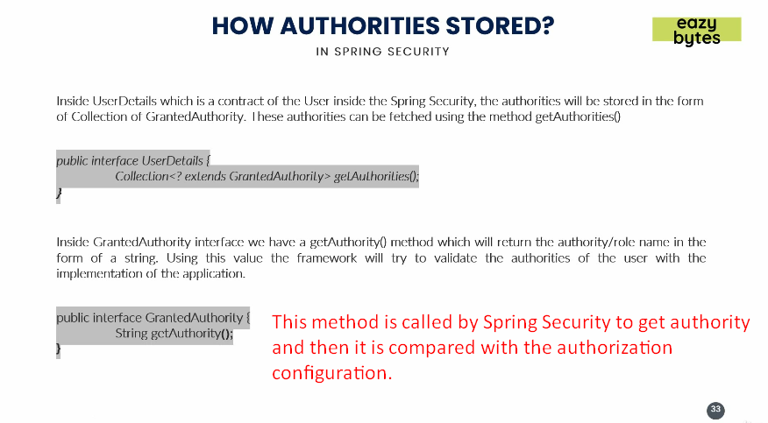
5. Let’s go inside the code to see it.
6. 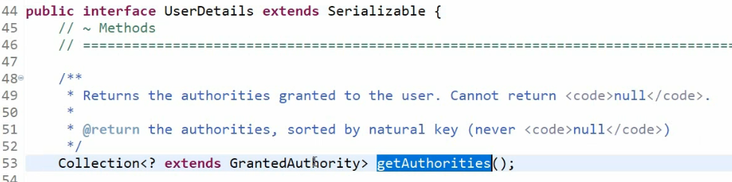
7. 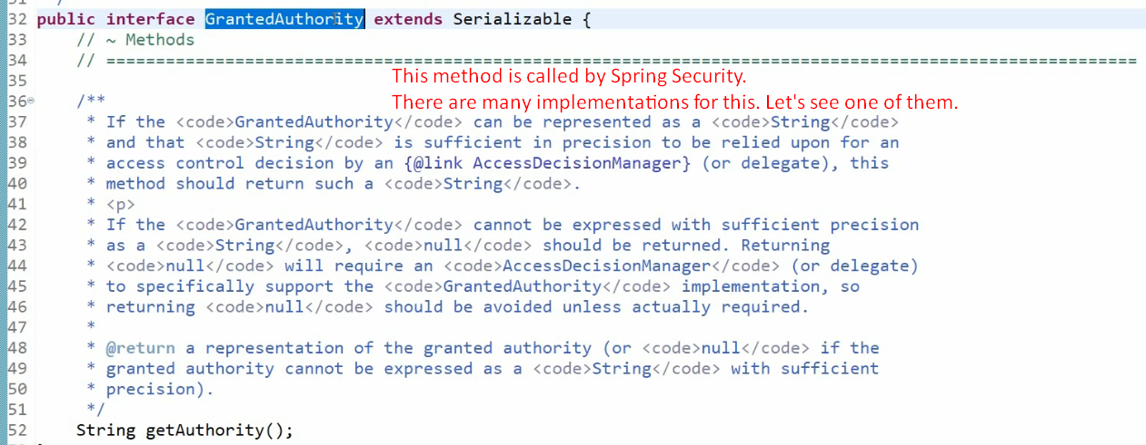
8. 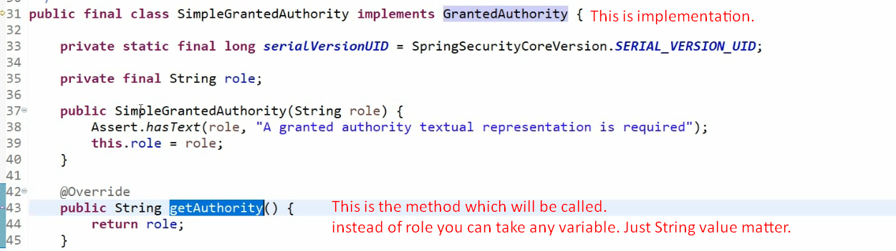
9. 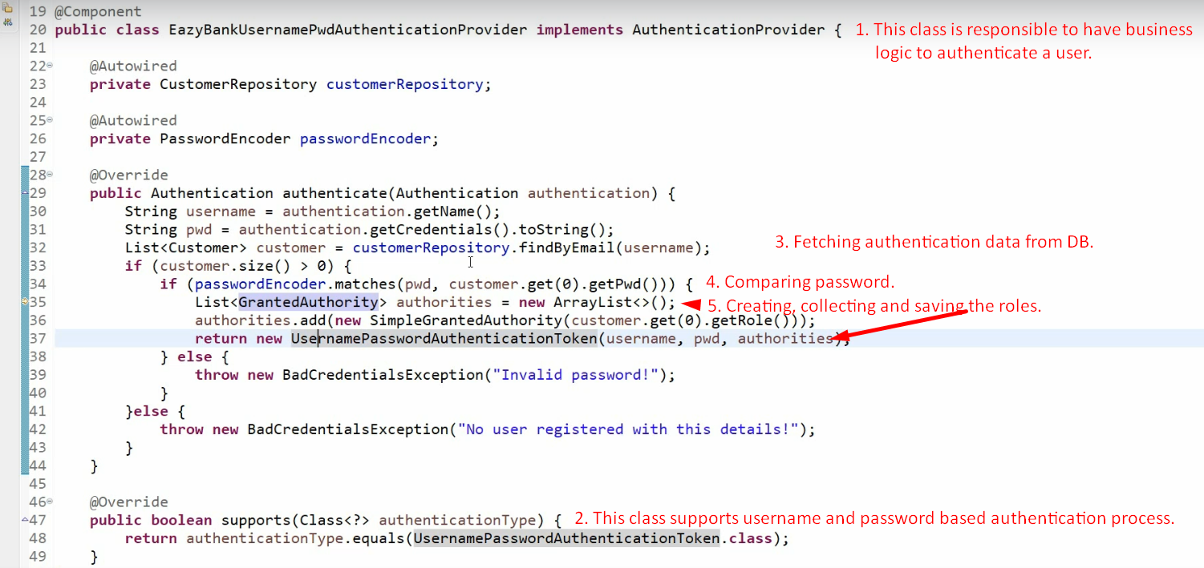
10. In next lecture, let’s see how to configure authorization in our app like   
    this user with this role should be able to access this API path.